Name:  Class: | ____________________________________  ________________ |  | Date: _________
 | Year 7 Mathematics  Mini-Test 3, 2018  Topic – Transformations and Angles |  | / 35  %
Total Time: | 40 min
Weighting: | %
Equipment: | Calculator, Protractor and 1 page of notes A4 (one sided).  *SHOW ALL WORKING OUT*

A Grade
Represents and describes, using coordinates, multiple combinations of translations, reflections in an axis and rotations of multiples of 90 degrees on the Cartesian plane.
Solves angle problems involving multiple parallel and/or transversal lines, justifying solutions and explaining reasoning.
B Grade
Represents and describes, using coordinates, translations, reflections in an axis and rotations of multiples of 90 degrees on the Cartesian plane.
With prompting, solves angle problems involving multiple parallel and/or transversal lines, justifying solutions and explaining reasoning.
C Grade
Represents translations, reflections in an axis and rotations of 90 degrees on the Cartesian plane.
Solves simple angle problems, justifying solutions by naming angle relationships involving a transversal line cutting a pair of parallel lines.
D Grade
Identifies translations, reflections in an axis and rotations of 90 degrees on the Cartesian plane.
Identifies and names simple angle relationships involving a transversal line cutting a pair of parallel lines.
E Grade
Does not meet the requirements of a D grade.

Teacher Feedback:

Part A – Multiple Choice –Circle only 1 answer 6 marks

Question 1 Use this space for your working
The complement of $37°$ is
- $57°$
- $53°$
- $147°$
- $143°$

Question 2
Which of the following is an example of an obtuse angle?
- $67°$
- $182°$
- $93°$
- $215°$

Question 3
A point $Q$with coordinates (-8 , -6) is reflected across the y-axis. What are its new coordinates?
- (6 , -8)
- (-8 , 6)
- (8 , 6)
- (8 , -6)

Question 4
Which of the following describes the translation of triangle 1 to triangle 2
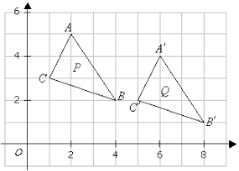
2
1
- 3 right, 1 down
- 4 right, 1 down
- 5 right, 2 down
- 6 right, 2 down

Question 5
If two angles are Vertically opposite it means the:
- Angles that add up to $90°$
- Angles that add up to $180°$
- Angles that add up to $360°$
- Angles that are opposite to each other when lines intersect

Question 6
If this shape is rotated 180$°$ clockwise, the new shape would look like

- B. C. D.

Part B – Short Answer ** Answer Each Question and Show Full working ** 29 marks

Question 7 [2 marks]
Measure the following angles and give the answer in degrees

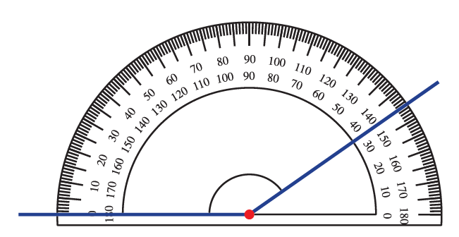
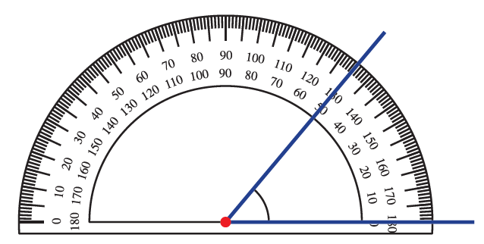

___________________ ___________________

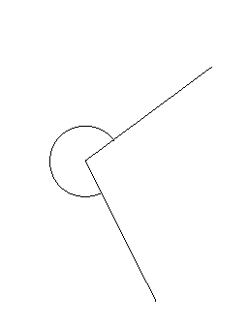
Question 8 [2 marks]
Using your protractor, measure the following angles and give the answer in degrees
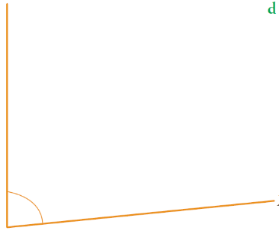
B.
A.

___________ ___________
Question 9 [1 marks]
Use a protractor and draw the following angles
- 135$°$

Question 10 [4 marks]
Without using a protractor, find the size of each angle marked with the letter a°
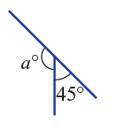
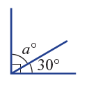
- B.

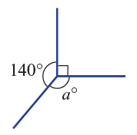
C.

Question 11 [6 marks]
Determine the unknown angle marked with the letter a° and give reasons
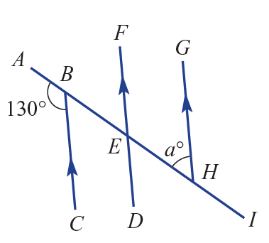
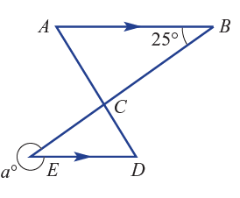
- B.

Question 12 [4 marks]
Mark the angle given (with the letter in the brackets) AND find the value of the angle in the following diagram

54$°$

- Corresponding (A$°$) _______________

- Alternate (B$°)$ _______________

- Co-interior (C$°$) _______________

- Vertically opposite (D$°$) _______________

Question 13 [6 marks]
Graph the triangle whose vertices have the coordinates given below.
R (1, 4) N (0, 2) P (-4, 3)
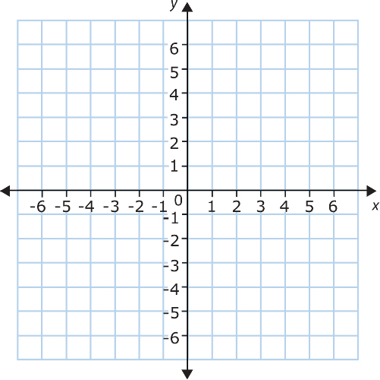

After reflecting along the $x-axis$ and translating 3 units down, what would the new coordinates be
R _________ N ___________ P __________

Question 14 [4 marks]
Determine whether the lines AB and CD are parallel or not. Justify your answer.

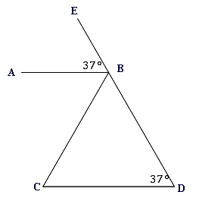
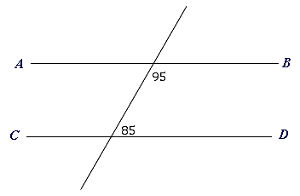
- B.

End of Test

